TECHNICAL PROJECT REPORT

# Title of Invention / ProjecT: VOICE CONTROL LED

# Team Members / Inventors:

|  |  |  |  |  |  |
| --- | --- | --- | --- | --- | --- |
| **S. No.** | **Name** | **Department** | **Designation** | **Mobile** | **E-Mail** |
| 1. | Saksham rana | CSE(AI&ML) | Team member | 8219870798 | Sakshamrana0104@gmail.com |
| 2. | Mayank virmani | CSE(AI&ML) | Team member | 9354544084 | Virmanimayank15@gmail.com |
| 3. | Abhishek koundal | CSE(AI&ML) | Team member | 9115898742 | Abhishekkoundel9017@gmail.com |
|  |  |  |  |  |  |
| 5. | Khushal Thakur | ECE | Mentor | 9646030764 | khushal.thakur@cumail.in |
| 6. | Anshul Sharma | ECE | Mentor | 9478697475 | anshulsharma.ece@cumail.in |
| 7. | Kiran Jot Singh | ECE | Mentor | 9463909689 | kiranjotsingh.ece@cumal.in |
| 8. | Divneet Singh Kapoor | ECE | Mentor | 9878422653 | divneet.ece@cumail.in |

Section – 1 (IPR Related)

# Brief Abstract (500 words):

1-problem your project is solving

Our project is solving the most common problem of now days. Now days people used to be very lazy and busy in their work. Most of the time when they leave from work they forget to switch off the lights by using this project we can switch off the lights from far distance by just connecting the Bluetooth and giving the voice message to switch off the light and turn on the light.

+> Before this product we can’t switch off the light in this way and lots of unit of light get wasted. But now it is quiet very easy for us to do this work.

2- How are you solving the solution?

The major problem of the circuit that is electrical safety can be ensured in our project because of use of very few jumper wires. Additionally no circuit is made within the reach of people. Every material that we have used in the project is put on a cardboard.

# Existing state-of-the-art and Drawbacks in existing state-of-the-art

(*Brief background of the existing knowledge*)

|  |  |  |
| --- | --- | --- |
| **S. No.** | **Existing state of art** | **Drawbacks in existing state of art** |
| 1. | Voice-controlled wireless COMMUNICATION | The connection and response of the device is very slow. |

# GOOGLE PATENT: US6892083B2

LINK: https://patents.google.com/patent/US6892083B2/en?q=voice&q=controlled&q=led&q=bluetooth&oq=voice+controlled+led+with+bluetooth

# Novel/Additional modifications that you can propose to improve upon drawbacks

# Advantages

Accessebility increases from far distances.

Less danger of shock.

Connectivity and response of the device is good.

Section – 2 (Real Project)

# Materials

1. Arduino uno x 1
2. LED+220 OHM resistor x 4
3. HC-05 bluetooth module x 1
4. M-F jumper wires x 10
5. 9v battery x 1
6. Battery cap x 1

Block Diagram:

BLUETOOTH

2 LEDs

MICROCONTROLLER

# Circuit Diagram

(*Fully functional circuit diagram with exact connections. Can use Fritzing/Proteus*) 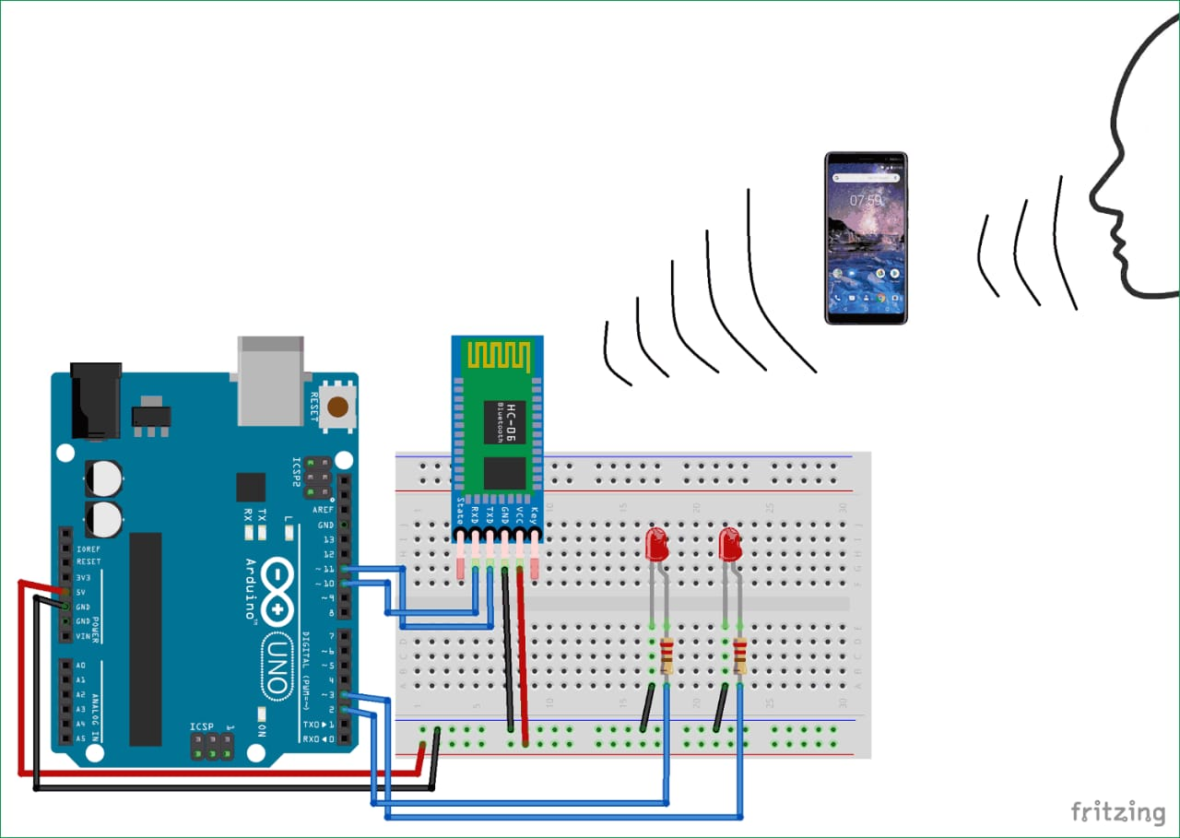

STEPS:

STEP 1: First we connected Bluetooth with Arduino using jumping wires.

STEP 2: Then we connected Arduino with the PCB Board using connecting wires.

STEP 3: Now, we connected the LEDs with the pcb board and grounded the LEDs with connecting wires.

Step 4: Then we connected resistances between the LEDs and the connecting wires coming from Arduino .

Step 5: At last we grounded the Bluetooth module and connected the battery cap with Arduino.

GITHUB LINK:

https://github.com/MayankVir/voice-controlled-light